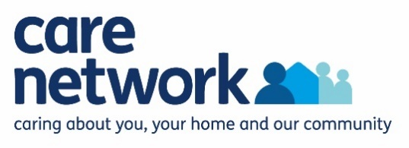

**Introducing our Healthy Homes and Memory Matters Service**.

Care Network is a local charity and we are commissioned by Blackburn with Darwen Public Health and the Better Care Fund. As part of our Healthy Homes Service, we work with vulnerable residents across the Borough to help them to keep their homes safe, warm and free from hazards and damp conditions.

**Eligibility** **for Healthy Homes**

Advice, information and signposting is available to all residents of Blackburn with Darwen, with more targeted interventions including a home visit and assessment available for residents who meet any of the following criteria : over 50, have a child under 18, receive means tested benefits, living with various disabilities, including LD & Autism, respiratory or circulatory disease, dementia and memory issues, mental illness, are at risk of falling or have been impacted by the cost of living crisis.

**Eligibility** **for Memory Matters**

* Our Memory Matters service is available to residents of Blackburn with Darwen who are living with any form of memory loss, including dementia, at any stage, even before diagnosis.

**Our offer includes**:

A home visit from one of our Healthy Homes Officers who will:

* Get to know and understand what people need to make their home more comfortable, safe and warm.
* Make sure people are getting the best deal on their gas and electricity bills – tariff checks and fuel switching.
* Give advice around home insulation, draught-proofing and other repairs.
* Help if people are struggling to keep their home warm or pay their fuel or water bills and make sure they know about other simple ways to keep their bills down.
* Help people to register on the Priority Services Register(s), so they can get assistance if there's a power cut or they do not have a water supply.
* Provide advice and guidance on how to keep homes free from unhealthy damp, mould and condensation.
* Help people to identify and reduce any risks around the home that may be putting them at risk of a slip, trip or fall.
* Let people know about equipment that makes moving around the home easier and safer for all ages.
* Let people know about other services and support to help their wellbeing and quality of life (through our Care Network Hub offer)
* Help people with memory issues to identify simple solutions to help with day-to-day tasks, visual and orientation problems or safety risks

**For more information, please get in touch**: Tel 01254 507255 (option 3)

Email: [healthy.homes@carenetwork.org.uk](mailto:healthy.homes@carenetwork.org.uk) Website: [www.carenetwork.org.uk](http://www.carenetwork.org.uk)